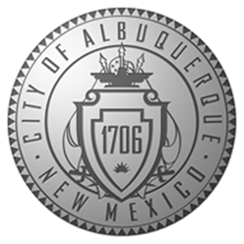
CITY OF ALBUQUERQUE

NOTICE OF REQUEST
FOR
LETTERS OF INTEREST

The City of Albuquerque is seeking a firm or firms experienced in economic development marketing to collaborate proactively to increase the awareness of Albuquerque within the U.S. (and potentially international) marketplace, and to promote the area as a premier location to potential entrepreneurs, businesses and industries seeking to relocate or expand their operations, or to potential investors in Albuquerque companies. Additionally, we want to increase awareness of Albuquerque as a positive place to live and grow a business among local residents.
This program will have a special focus on audiences within the startup community, including business founders, investors, management and workforce talent, and their influencers. The primary goal is to position the Albuquerque area as a vibrant center for entrepreneurship. The goal is to increase the frequency of Albuquerque’s inclusion in expansion/relocation considerations and to increase the incidence of quality economic expansion.

Respondents are welcome to respond individually or in teams. If the City accepts more than one separate Letter of Interest from qualified respondents, the chosen entities will be required to contractually agree to collaborate with each other in carrying out the services for the City. The City reserves the right to negotiate with members of one or more teams on the terms of the final contract.

Issuance Date: August 21, 2015
Due Date: Wednesday, September 23, 2015 at 5 p.m. Mountain Daylight Time
(Due date and time shall be strictly observed.)

City of Albuquerque
Economic Development Department

